*Overall Multidisciplinary Projec*t

*SEM Programme & SGB Master*

Load Forecasting Using Learning Techniques: EV Charging Stations

*Project Report*

*16/01/2023*

***Authors***

Oscar Wahlström oscar.wahlstrom[@grenoble-inp.org](mailto:xyz@grenoble-inp.org)

Camille Fournier camille.fournier2@grenoble-inp.org

Yann Le Floch [yann.le-floch2@grenoble-inp.org](mailto:yann.le-floch2@grenoble-inp.org)

Anujraaj Gopalsamy Sakthivel [anujraaj.gopalsamy@grenoble-inp.org](mailto:anujraaj.gopalsamy@grenoble-inp.org)

***Supervisors***

Manar Amayri [manar.amayri@grenoble-inp.fr](mailto:manar.amayri@grenoble-inp.fr)

Nana Kofi Baabu Twum Duah [nana-kofi-baabu.twum-duah@g2elab.grenoble-inp.fr](mailto:nana-kofi-baabu.twum-duah@g2elab.grenoble-inp.fr)

# Abstract

To meet the objectives of the energy transition, the use of Renewable Energy Resources is increasing and will be increasing drastically. In parallel, the development of electric mobility with low-carbon electricity is also a solution explored to reduce the emission of greenhouse gasses. Nonetheless, the growth of this new mobility implies new constraints on the grid as the electrical consumption will increase to load the vehicles. In fact, according to RTE (French Transmission System Operator), in 2035 the projected consumption of Electrical Vehicles (EV) will account for approximately 8% of France‘s total electricity production [1]. However, it can be noted that the increase in EVs also provides new flexibility opportunities for the grid such as “charging with real-time load balancing in the power grid” or “bidirectional charging combined with photovoltaic (PV) self-consumption” to name a few [1].

This paper analyzed the time series of an EV charging station located on the premises of the GreEn-ER building (which houses Grenoble-INP ENSE3). The main objective of this work was to build a predictive model for a Model Predictive Control (MPC) application using Python programming language.

To do so, work done by a previous groupon the development of a predictive model for an MPC to increase the self-consumption of the Predis MHI platform was studied. Following the review of their work, EV data from the station was analyzed to be preprocessed (removing outliers and normalization). Then, a selection of promising models tested by the previous group was taken to be tested on the EV data set. In particular, Long Short-Term Memory networks (LSTM) and Convolutional Neural Network (CNN)-LSTM models were first tested. The CNN-LSTM model showcased better performance. Thus, it was kept to see if the addition of additional features could increase its performance. Lastly, the use of clustering was also studied and showed promising result

Contents

**Abstract** **1**

**List of Tables** **2**

**List of Figures** **2**

**1. Introduction** **4**

**2. Theoretical Background** **4**

2.1. Problem statement 4

2.2. Bibliographic review 5

2.2.1 Pre-processing 5

2.2.2 Forecasting Methods 5

**3. Methodology** **6**

3.1. Data pre-processing 7

3.1.1. Outliers 7

3.1.2. Exploratory Data Analysis 8

3.2. Features 10

3.2.1. Temperature 11

3.2.2. Calendar 12

3.2.3. Electricity price 12

3.2.4. Personal habits 12

3.3. Clustering 13

3.3.1. Methodology 13

3.3.2. Obtained clusters and analysis 14

**4. Results** **15**

4.1. Condition of the results 15

4.2. Results obtained and analysis 15

**5. Discussion** **16**

5.1. Analysis of the results 16

5.1.1. Why overall results are worse than that of the previous year 16

5.1.2. Influence of the features for the models without clustering 16

5.1.3. Issues with the habits feature 18

5.2. Problems Encountered 18

5.2.1. Understanding previous work 18

5.2.2. Lack of Data 18

6. Conclusion 19

**7. Bibliography** **20**

**8. Appendix** **21**

# List of Tables

*Table 1: Scores obtained by the 2020 group from a pool of different methods 6*

*Table 2: Statistical Analysis of EV Data and Conso Global Data 9*

*Table 3: Values applied depending on user preferential day to charge* 13

*Table 4: R-Score of the different ML models with varying features* 16

*Table 5: Performance of difference classifier predictor models 16*

*Table 6: Influence of features- Increase or decrease of R-Score for 1H and 3H prediction 18*

# List of Figures

*Figure 1: Description of the studied system 7 Figure 2: Display of charger consumption data after removing “clear“ outliers* 7

*Figure 3: Display of the aggregated and then normalized aggregated consumption 8*

*Figure 4: Autocorrelation plots for EV time series 10*

*Figure 5: Partial autocorrelation plot for EV time series 10*

*Figure 6: EV time series decomposition. 10*

*Figure 7: Li-ion battery capacity variation with temperature* 11

*Figure 8: User usage of their EV depending on the weather, extract of the form submitted to school EV users 12*

*Figure 9: Preferential day to charge the EV for users of the school's chargers 13*

*Figure 10: Silhouette score for k-means clustering of EV time series 14*

*Figure 11: Answers of EV users concerning the effect of weather on their EV use 18*

*Figure 12: prediction and R2-score results (green curve) for the CNN-LSTM model with calendar as a feature 19*

# Introduction

Electric Vehicles (EVs) are currently seen as an opportunity to reduce greenhouse gasses in the transport sector, help address local air pollution, and overcome the uncertainties posed by the dependence on fossil fuel import as spotlighted by recent geopolitical events. Many governments are consequently incentivizing EV use, and some regions of the world have even planned to ban the sale or use of combustion-engine vehicles in the mid-term (by 2025 in Norway, by 2030 in Germany, the UK, and the Netherlands, and by 2040 in France, for instance). More recently, COP26 signatories have agreed to commit to 100% zero emissions transport by 2040 [2].

Furthermore, battery costs are expected to decrease in the coming decades. Therefore, the share of EVs in the transport sector is forecasted to surge in the next few years. EV sales in Europe continued to increase by more than 65% in 2021. The International Energy Agency's 2030 scenario forecasts that half of all vehicle sales in Europe could be EVs by 2030 and stresses the critical importance of careful planning and fostering smart charging [3]. In the case of France, the country has set 2040 as the target year for ending sales of new fossil fuel-powered passenger cars and light commercial vehicles. In 2021, France experienced a significant increase in electric Light Duty Vehicles (LDV) sales, likely due to its ecological bonus program which provides subsidies for Zero Emission Vehicles (ZEV) purchases under its Covid-19 economic package, France Relance, which was extended to mid-2022. The French president has also set a target of 1 million Battery Electric Vehicles (BEVs) and Plug-in Hybrid Electric Vehicles (PHEVs) to be produced in France by 2025 [4].

The significant growth of the EV industry brings new challenges to the power systems caused by the introduction of large battery capacity and uncertain charging behaviors of EV users. This potentially results in significant peak-to-valley differences in load particularly in a super-short-term time scale, thus degrading the power quality. Therefore, utilities and other power producers need to be prepared to meet the increased loads as transportation electrification grows, and to be able to forecast required electricity with a minimum error, to maintain stable and effective power system operation, although the characteristics of the EV demand (i.e., non-constant patterns, seasonal effects, weather and social correlation, high volatility and jumps) complicate the load forecasting problem. New smart charging opportunities are also to be taken. EV batteries could be used coupled with photovoltaic self-consumption. RTE describes the process as “*charging and potentially discharging takes place in such a way as to make the best use of energy generated locally by PV panels*” [1]. Optimizing the use of EV’s battery for PV self-consumption thus requires the use of a predictive controller. Therefore, the accuracy of EV charging forecasts is essential to support the development of smart charging.

To forecast EV charging load, the use of forecasting models built with machine learning is possible and a promising path. Machine learning can use existing consumption data and other relevant variables (features) to build a model and train it. Two types of methods may be used in machine learning: supervised and unsupervised learning. In the first one, the model is trained using the features as well as the output that should be obtained. In the case of unsupervised learning, the results are unknown and the model aims at identifying classes or clusters in the data.

The objective of this work is to build predictive models with machine learning for an MPC to forecast the short-term charging load of EV chargers present in the parking lot of the engineering school Grenoble-INP ENSE3. This work builds on previous work done in previous years to develop a forecasting model for the consumption of the Predis-MHI platform in the school. Thus, our objective will be to study if the models they developed can be used with EV data and if not adapt or improve them to obtain the best forecasting accuracy possible.

# 2. Theoretical Background

## 2.1. Problem statement

To meet goals for transitioning to a low-carbon world, the implementation of various strategies, including increasing the use of Renewable Energy Resources (RERs) is necessary. While these resources are good for the environment, they can pose technical challenges, particularly for grid operators due to their intermittent nature. One way to address these challenges is through self-consumption, which involves using the energy generated by RERs at the source, reducing the impact on the grid. To maximize self-consumption, it is important to use available flexibilities, such as adjusting energy demand to match generation profiles, to adapt to the intermittent nature of RERs. For example, in the context of the building of Grenoble-INP ENSE3 with an EV charging station, the charging station could be used as an indirect flexibility (impact of human behavior, in EVs, charging when users plug or unplug their vehicles) to optimize self-consumption by implementing a Model Predictive Controller that allows for day-ahead optimizations and sends optimal charging schedules to EV drivers.

## 2.2. Bibliographic review

### 2.2.1 Pre-processing

Since the data used by last year's groups are different from ours, the pre-treatment of the data will naturally differ. However, it is interesting to evoke the strategies used previously as we could either try some of them or improve them for our own set of data.

In 2020, the group working on the project decided to treat outliers in their consumption data by removing them from the dataset. The 2021 group decided to change that and replace outlier values with data from the same hour from the previous week. This particular strategy yielded better results in terms of R-score (a metric for evaluating predictions).

### 2.2.2 Forecasting Methods

Last year groups used 5 different forecasting methods that are shortly presented here:

* **Naive prediction:**

A naive classifier model is one that does not use any sophistication in order to make a prediction, typically making a random or constant prediction. Such models are naive because they don’t use any knowledge about the domain or any learning in order to make a prediction. In the case of the MHI platform, assigning the value of the same hour of the same day the previous week to the value of the hour to predict. This method is used as a benchmark.

* **ARIMA:**

ARIMA stands for *Auto-Regressive Integrated Moving Average*. ARIMA is a statistical method that is often used for analyzing time series. ARIMA is an extension of the ARMA model for non-stationary time series. ARMA is using, on one hand, an autoregressive method (namely using a certain number of past values for predicting future ones) and on the other hand a moving average method (namely saying that future values are dependent on the mean of the time series plus a white noise).

* **LSTM:**

LSTM stands for Long Short-Term Memory. LSTM is part of the Recurrent Neural Networks (RNN) models group and more broadly part of Deep Learning. RNN models have the ability to remember previous states for predicting future ones which is relevant for time series. The particularity of LSTM is that it is combining both short-term memory and long-term one. LSTM can be efficient if there is good management of the dropout (capacity of the model to forget some information) for avoiding overfitting.

* **CNN-LSTM:**

CNN stands for Convolutional Neural Network. CNN-LSTM is an improvement of LSTM where a CNN model is used upstream from the LSTM model. By doing this, it is hoped that the seasonal behavior will be better caught.

LSTM and CNN-LSTM are used with different inputs:

* the past consumption data
* the past data of occupancy and temperature (either daily average or not)
* the future data of occupancy and temperature.

The results obtained by the 2020 group are summed up in Table 1. The results are assessed using R-score.

*Table 1: Scores obtained by the 2020 group from a pool of different methods*

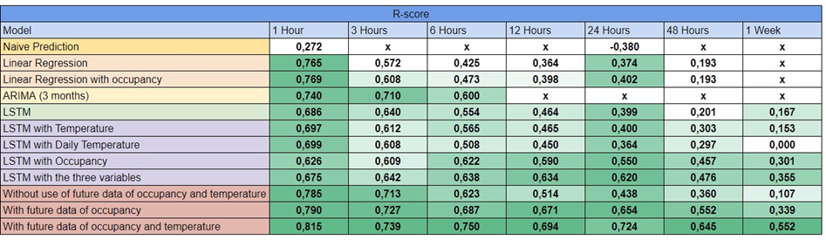

The 2021 group best model was obtained using a light GBM model with clustering of the consumption profile in four classes. Five features were used to train the model:

● Binary calendar based on the school calendar (1 value)

● Electrical consumption of the last 24 hours (24 values)

● Hourly consumption of day D-7 (24 values)

● Class of the day D-7 (clustering). (1 value)

● The average outdoor temperature over the last 24 hours (1 value)

With those, the R2-score calculated for a prediction of the next 24 hours for the whole testing period was 0,74. A slight increase compared to the 2020 best model.

# 3. Methodology

The studied system of this project is the Predis-MHI platform, a living lab located on the premises of the GreEn-ER building of Grenoble-INP ENSE3. The platforms is composed of 600 offices, teaching and experimental rooms, EV charging stations on the parking lot adjacent to the building, solar PV of 22 kWp, a battery of 50 kWh and a connection to the electric grid. It can be noted that the charging stations is composed of four chargers:

* Two chargers of 2 times 7 kW capacity initially present
* Two chargers of 2 times 22 kW capacity added in 2021

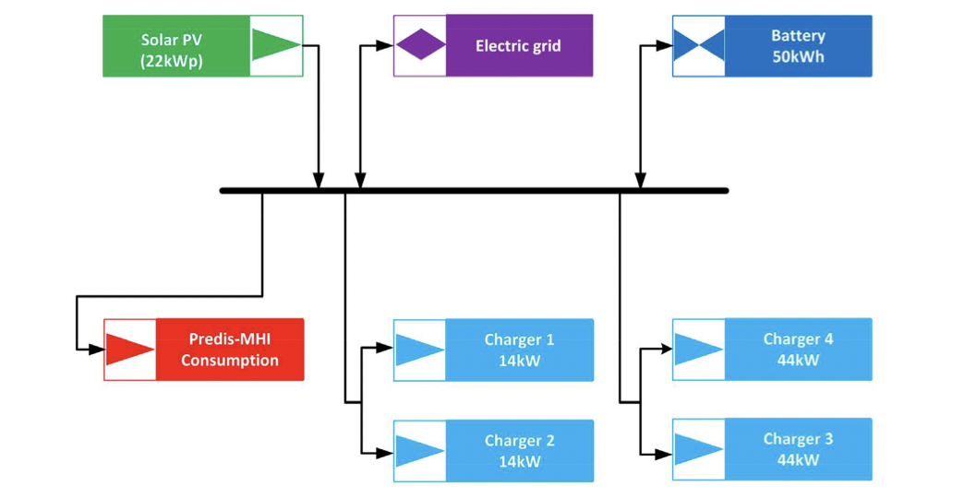

*Figure 1: Description of the studied system ( extracted from [6])*

As explained in the introductory part, our work differs from last year's groups as we will be using EV consumption data, and not the PREDIS platform datasets. Furthermore, it can be assumed that trends found in building consumption are different from EV charging since some parameters (features) will not have the same influence on consumption. Thus, our work will be centered on adapting the previous groups' models to our data and identifying which features are most useful to increase the performance of our forecast.

## 3.1. Data pre-processing

### 3.1.1. Outliers

Since for this project the data were never treated before, it is particularly important to study it to identify outliers in the data so we may work on a clear set of data. The data given for this project starts in 2016 however the charging frequency was low before 2020. Thus, it was decided to only work on the data starting by the first of January 2020. By displaying the value for each charger, it can be noticed that there are clear outliers (values above the hundredth). To treat these outliers, it was decided to remove them and replace the nan value by using the interpolation method forward fill (i.e., replace with the previous value).

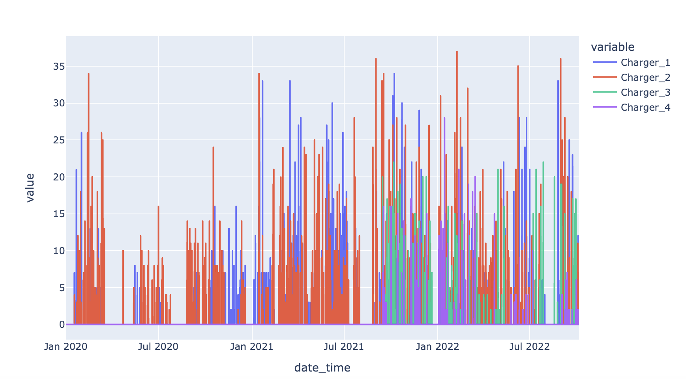

*Figure 2: Display of charger consumption data after removing “clearly visible“ outliers*

Furthermore, it was also noticed that some values were in a range between 0 and 1. However, the resolution of the measurement doesn't go into decimals which means those values should be zeros (and in reality, are mostly the energy consumed by the chargers themselves). We replaced all values below 1 with zeros.

After a closer examination of the data and discussion with our supervisors, an issue was also identified with the data of chargers 1 and 2. During the measurement of the consumption, there had been disconnections of the transmission of data which resulted in high peaks of consumption when the transmission was reestablished (the device was communicating the sum of what it had measured for multiple hours during the disconnection as the value for the hour when reconnection occurred).

To solve this issue, values measured above what the charger can normally charge in an hour were spread over the previous 3 hours (code is available in Appendix 1).

Finally, for our model, we decided to sum all charger consumption values as one to simplify the prediction (reduce the randomness). Those aggregated values were then normalized (values are in a range of 0-1 to eliminate the effect of introducing other features measured on different scales (A. Subasi, 2020) later on in our project).

The results of this process can be seen in Figure 3 below:

|  |  |
| --- | --- |
| image10.png(a) | image4.png(b) |

*Figure 3: Display of the aggregated (a) and then normalized aggregated consumption (b)*

### 3.1.2. Exploratory Data Analysis

An Exploratory Data Analysis (EDA) is a strategy to investigate and analyze data sets to gather knowledge visually. EDA is used to comprehend a dataset’s important aspects. Table 2. shows the important statistical parameters of the EV data. The last column of the table compares the new EV data with the previous year’s consumption data, which is further developed in the upcoming chapter to compare the performance of machine learning models. As shown in Table 2 the EV data has a huge volume of zeroes, which shows that the EV chargers are not in use for significant time periods. ADF test results show that the EV data is stationary with no inbuilt trend, which is further explored later.

*Table 2: Statistical Analysis of EV Data and Conso Global Data*

|  |  |  |  |  |  |  |
| --- | --- | --- | --- | --- | --- | --- |
| **Statistical Parameters** | **EV Data** | | | | | **Previous year data** |
| **Charger 1** | **Charger 2** | **Charger 3** | **Charger 4** | **Aggregate** | **Predis-MHI demand** |
| **Alerts from Panda Profile report** | (98.0%) zeros | (96.5%) zeros | (98.5%) zeros | (99.1%) zeros | (92.1%) zeros | Skewness, Duplicate rows (0.8%) |
| **Augmented Dickey-Fuller Test Results** | | | | | | |
| **ADF Test Statistic** | -18.65 | 19.31 | 17.75 | -25.28 | -17.86 | -47.08 |
| **P-Value** | 2.05e-30 | 0 | 3.35e-30 | 0 | 3.05e-30 | 0 |
| **# Lags Used** | 48 | 48 | 47 | 30 | 47 | 22 |
| **# Observations Used** | 24160 | 24160 | 24161 | 24178 | 24161 | 59248 |
| **Critical Value (1%)** | 3.43 | 3.43 | -3.43 | -3.43 | -3.43 | -3.43 |
| **Critical Value (5%)** | 2.86 | 2.86 | -2.86 | -2.86 | -2.86 | -2.86 |
| **Critical Value (10%)** | 2.56 | 2.56 | 2.56 | 2.56 | -2.56 | -2.56 |
| **Is the time series stationary?** | True | True | True | True | True | True |
| **Zeros (%)** | 98% | 96.5% | 98.5% | 99.1% | 92.1% | 33.4 % |
| **Minimum** | 0 | 0 | 0 | 0 | 0 | 0 |
| **5-th percentile** | 0 | 0 | 0 | 0 | 0 | 0 |
| **Q1** | 0 | 0 | 0 | 0 | 0 | 0 |
| **Median** | 0 | 0 | 0 | 0 | 0 | 1 |
| **Q3** | 0 | 0 | 0 | 0 | 0 | 2.99 |
| **95-th percentile** | 0 | 0 | 0 | 0 | 3 | 6.99 |
| **Maximum** | 14 | 14 | 22 | 27.99 | 33 | 8177 |
| **Range** | 14 | 14 | 22 | 27.99 | 33 | 8177 |
| **Interquartile range (IQR)** | 0 | 0 | 0 | 0 | 0 | 2.999 |
| **Standard deviation** | 0.90 | 1.17 | 0.93 | 0.68 | 2.02 | 81.78 |
| **Coefficient of variation (CV)** | 7.91 | 5.94 | 10.37 | 14 | 4.48 | 26.62 |
| **Kurtosis** | 95.63 | 53.99 | 232.31 | 465 | 49.91 | 6564.12 |
| **Mean** | 0.11 | 0.19 | 0.09 | 0.04 | 0.45 | 3.07 |
| **Median Absolute Deviation (MAD)** | 0 | 0 | 0 | 0 | 0 | 1 |
| **Skewness** | 9.27 | 6.99 | 14.11 | 19.64 | 6.22 | 78.19 |
| **Sum** | 2769.82 | 4785.12 | 2182.97 | 1181.99 | 10919.92 | 152085.59 |
| **Variance** | 0.81 | 1.38 | 0.87 | 0.47 | 4.08 | 6689.08 |
| **Monotonicity** | Not monotonic | Not monotonic | Not monotonic | Not monotonic | Not monotonic | Not monotonic |

The following plots show the autocorrelation of EV time series and its first order and second order differencing. This is performed to determine the q order for the ARIMA model, since there are no significant lags other than lag 1, q is taken as 1. To determine the p order the partial autocorrelation is plotted, which gives p = 3.

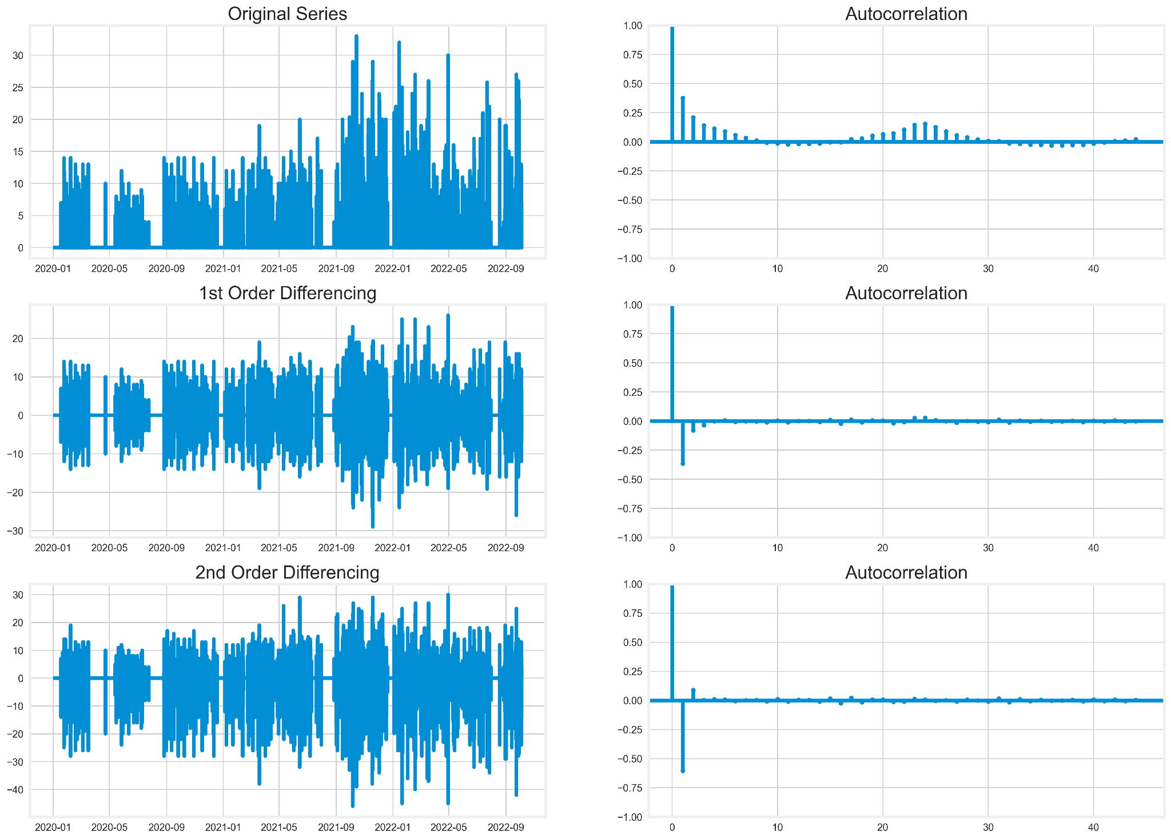

*Figure 4: Autocorrelation plots for EV time series*

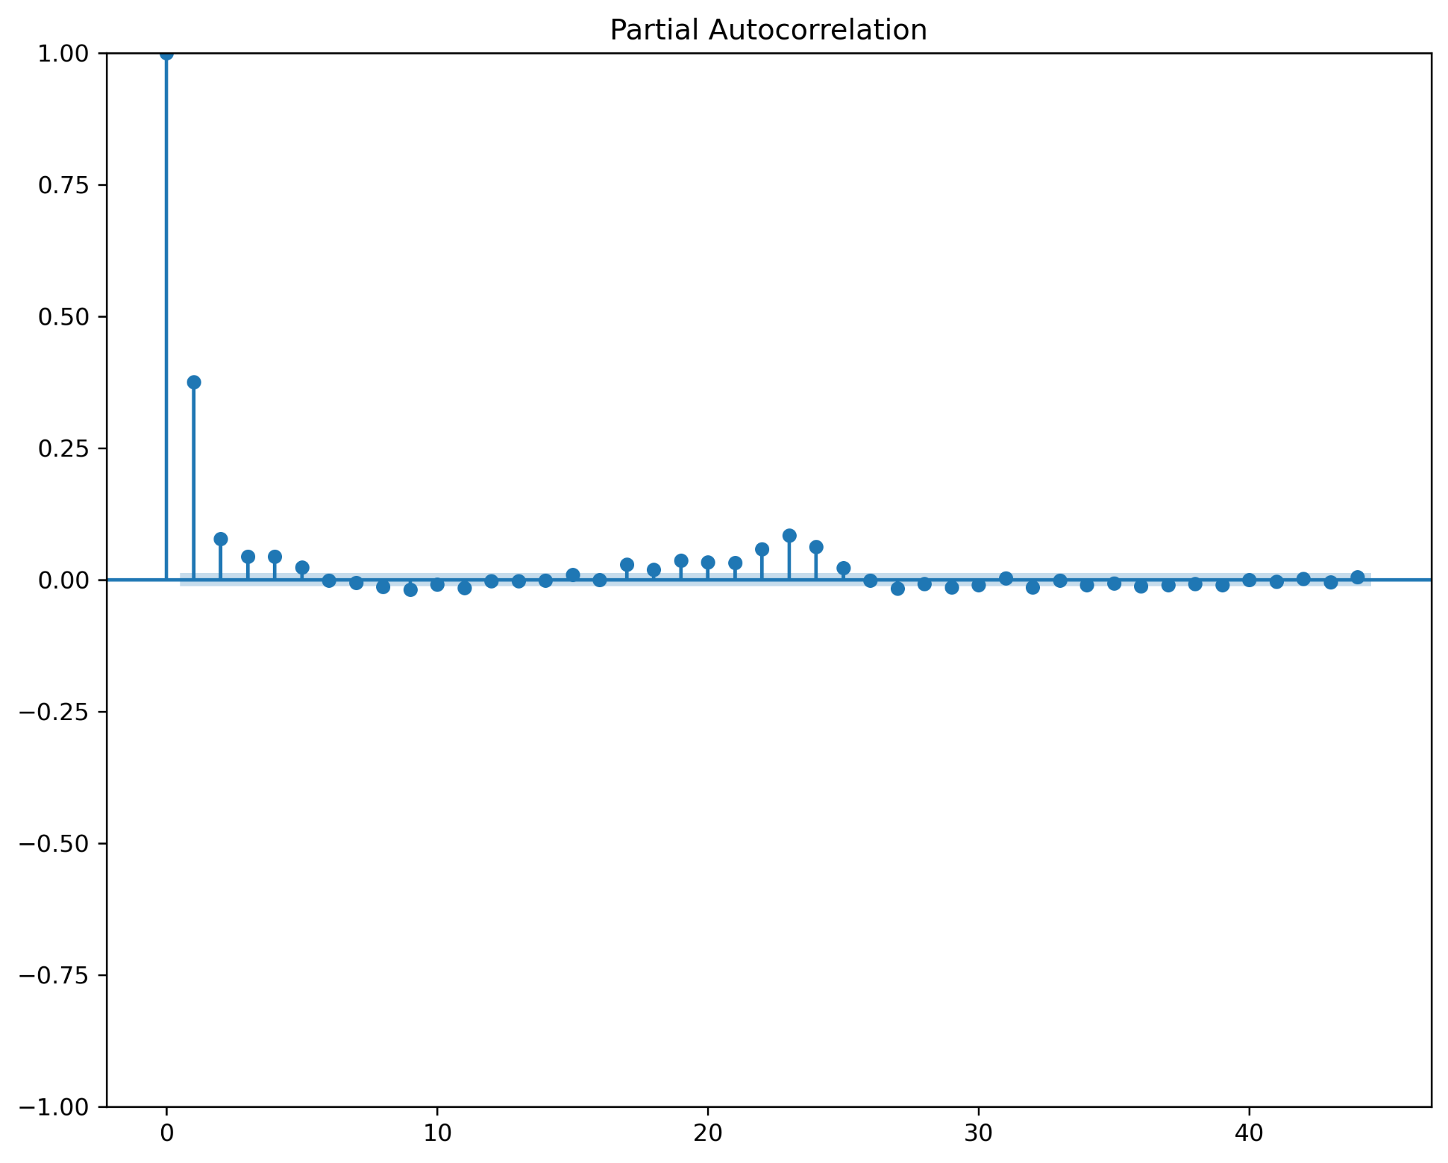

*Figure 5: Partial autocorrelation plot for EV time series*

The time series is further decomposed into trend, seasonality, and residual parameters as shown in Figure 6. The trend shows a gradual increase in the usage of EV chargers in the years peaking and plateauing around October 2021. There is a significant one week, 3 months, 6 months, and 12 months seasonality pattern.

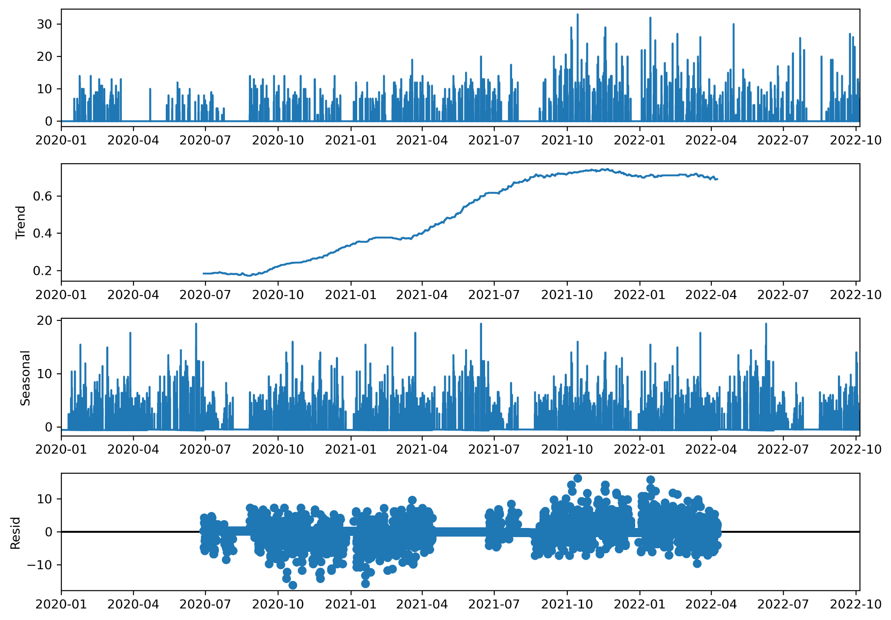

*Figure 6: EV time series decomposition.*

## 3.2. Features

In this section, the features we could use for our model will be further discussed and analyzed. Both the process behind implementing them and the thought process behind our feature selection is presented.

Features are the basic building blocks of datasets and play a key role in machine learning. These features are the independent variables in machine learning models that directly impact the quality of the results. Choosing informative and independent features is therefore a crucial element when optimizing our method to accurately achieve an accurate forecasting model. The implementation of additional features to the original dataset (consumption in our case) can have positive impacts on the accuracy of the machine learning model. It is therefore most important to study different features that might affect our model.

The power consumption of the studied chargers is directly linked with the amount of charging EVs. It is therefore interesting to analyze features that can have an effect on EV usage. These can then be added to create a more complex model that can make better and more accurate predictions. It is hard to in advance know what kind of impact additional features will have, depending on our data they might increase or decrease the accuracy. These features can also be combined to even further improve our model.

The studied features were temperature, calendar, consumption, electricity price, and personal habits. Information on these features and how they may influence EV users was studied through the use of a questionnaire sent to all EV users in the school. Below the implementation and decision behind each of these features will be further explained.

### 3.2.1. Temperature

*Analysis of the feature*

The relationship between outdoor temperature and household electricity demand is a subject that has been studied and confirmed by a lot of studies [7]. However, the correlation between outdoor temperature and the power consumption load of EV chargers is not as obvious. Through research and a Google form (see appendix) two possible hypotheses regarding outdoor temperatures' possible effect on consumption were recognized. One of the theories regarding a connection between temperature and consumption is correlated to the fact that Lithium battery capacity is strongly connected to temperature (see Figure 7) [8]. The colder temperature could therefore lead to an increased battery discharge before reaching the chargers which then would result in an increased load on the chargers. `

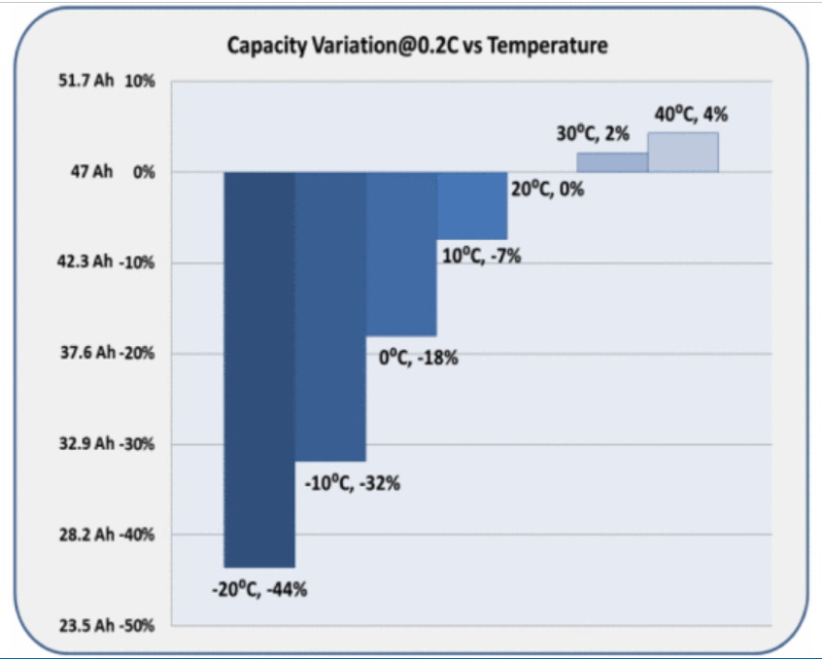

*Figure 7: Li-ion battery capacity variation with temperature [8]*

The second theory is based on the idea that the outdoor temperature affects people's decisions regarding taking their EVs to work. It is easily imaginable that someone living close to work would choose their bike instead of EV during sunny summer days while the opposite on cold winter days. A survey conducted for EV users in the building confirmed this assumption (see Figure 8).

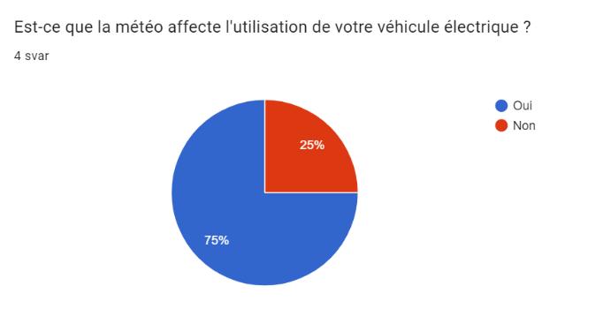

*Figure 8: User usage of their EV depending on the weather, extract of the form submitted to school EV user*

Now that we have concluded that temperature is an interesting feature to analyze we need to implement it in our model.

*Implementation*

To implement temperature as a feature in our model, temperature values were extracted from the weather station of the building. Since data were given with a timestep of 10mins, the dataset was resampled to a timestep of 1 hour like the consumption data of EV charging stations. The values were also normalized.

### 3.2.2. Calendar

*Analysis of the feature*

The calendar's impact on consumption is clear and needs no in-depth explanation. If the building is closed, then access to the charging station is also prohibited. There will not be any usage of the chargers. The calendar is the data related to the occupancy of the building. When it is expected that the rooms in question will be occupied due to the calendar, the value will be 1, while being 0 when no occupancy is expected. Since this data is not gathered by a sensor but is instead defined in the systems of the school, while also being a Boolean value, there are no outliers to deal with or pre-processing to be done. Generally, occupancy plays a major role in load forecasting because of the strong correlation between these two variables. It is also important to predict abnormal consumption patterns, like on the weekends, when consumption is usually low.

*Implementation*

As described previously, the calendar is implemented with 0 when there is no occupancy and with 1 when there is expected occupancy. No occupancy is set for:

* French holidays
* Saturdays and Sundays
* Covid lockdown days
* Lab summer closing
* After 20h and before 7h

### 3.2.3. Electricity price

The use of pricing mechanisms or dynamic pricing schemes is considered as a tool by companies to manage the time at which EV owners will use chargers. As an example, when electricity demand is lower in off-peak hours. As such, the electricity price can be considered as a feature to implement to manage consumption and reduce the strain on the grid. This can help to smooth out the overall electricity demand and reduce the need for expensive grid upgrades.

Having made this observation, we looked to see if we could implement this information into our prediction methods. First, we looked for more information about the changes in electricity prices. First, we wanted to see if the evolution of electricity prices at the consumer level had an impact on consumption, but it is difficult to find a trend by taking each consumer individually. So, we looked for price changes on the wholesale market to find trends in price changes over a year and see if we could find links with our data. However, users charging their electric vehicles at school do not have to pay for electricity, and we were unable to find good enough data to mine and use in our prediction models.

### 3.2.4. Personal habits

*Analysis of the feature*

What makes one feature more interesting than another one is how well and much that feature affects the power consumption of the chargers and therefore indirectly the users’ charging habits, such as weather and calendar. In the survey another possible, more direct, the feature was discovered to possibly have an impact; specific charging habits depending solely on which weekday it was.

It is not unreasonable to imagine that some of the users charge their vehicle more often on some days than others because of different personal reasons not affected by the earlier studied features. The user survey form resulted in the figure below which shows a weekly uneven usage of the chargers.

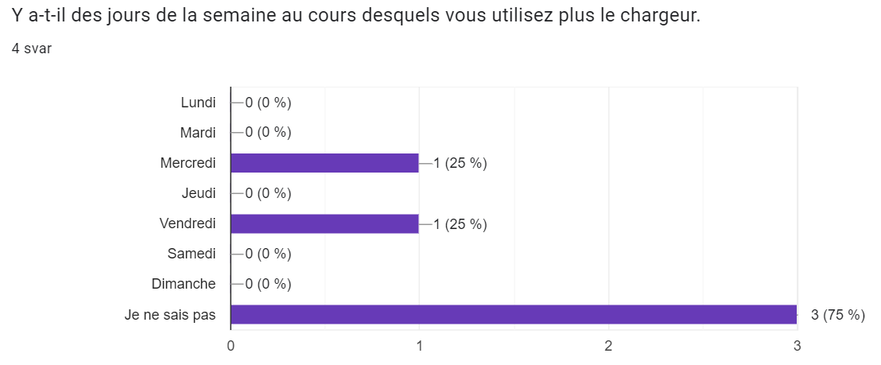

*Figure 9: Preferential day to charge the EV for users of the school's chargers*

*Implementation*

This feature was implemented in a manner similar to that of the calendar. They are both originally based on the same Calendar feature but differ in the normalization and valuation of days. The information gained through the form and the usage of the normalization formula: resulted in the following daily “importance” values. The weekends were set as zero because the answers in the form are only dependent on weekdays:

*Table 3: Values applied depending on user preferential day to charge*

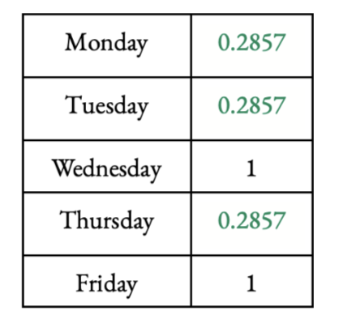

## 3.3. Clustering

We implemented a clustering method, which is an unsupervised learning process. The idea of this technique is to find similarities in the unlabeled data and then group similar data points together in sets. Clustering can help us gain insight into underlying patterns of different groups and might increase our final models performance. A distance metric, such as Euclidean distance, is used to assess how similar two data points are to one another. It is simply this metric that decides how closely related two data points are to each other which is used to place the points into their respective group. The goal of this unsupervised machine learning technique is to find similarities in the data point and group similar data points together.

The most typical method for grouping time series is to directly apply well-used clustering algorithms like k-means by flattening the time series into a table with a column for each time index (or aggregate of the series). By dividing samples into k groups and minimizing the sum-of-squares in each group, the popular clustering technique K-means creates data clusters.

### 3.3.1. Methodology

Due to the high randomness in the EV time series data as evident from the high volume of zeroes from Table 2, with prolonged time steps of unused EV chargers, the idea behind this methodology is to group the time series data into k-clusters which represent low, medium, and high consumption and predict these levels of consumption.

### 3.3.2. Obtained clusters and analysis

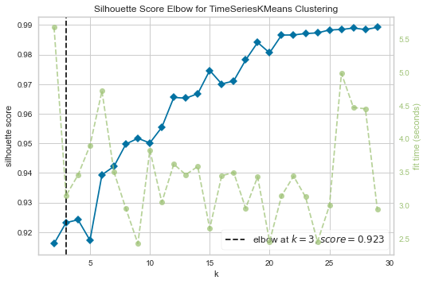

*Figure 10: Silhouette score for k-means clustering of EV time series.*

The separation distance between the generated clusters can be investigated using silhouette analysis. When the silhouette coefficients (as these values are known) are close to +1, it means that the sample is far from the nearby clusters. Indicated by a value of 0, a sample is on or very near the boundary between two neighboring clusters, while negative values suggest that the sample may have been mistakenly placed in the incorrect cluster. The ideal number of clusters, which in the case of the EV data is 3, is determined using the silhouette method, as illustrated in Figure 6.

The labels obtained 0,1, and 2 correspond to low, medium, and high levels of consumption based on the values of their cluster centers 0.1, 6.5, and 15.7 respectively.

The cluster labels are used in two different ways,

1. As a feature to CNN-LSTM model to predict the actual value of EV charger consumption and study if this improves the model or not.
2. Due to the less use of EV chargers and high volume of zeroes in the data, the second line of thought is to predict the level of EV consumption as low, medium, and high instead of predicting the actual value of consumption. Since, the three clusters neatly represent the low, medium, and high levels of consumption, the cluster labels are predicted using classifier predictor models.

The series of these cluster labels is then split into train and test data and predicted using Decision Tree, Random Forest, AdaBoost, and Gradient Boosting classifier predictor models, whose workings are explained below.

A **Decision tree** is a flowchart-like tree structure, where each internal node denotes a test on an attribute, each branch represents an outcome of the test, and each leaf node (terminal node) holds a class label.

The **Random forest** classifier creates a set of decision trees from a randomly selected subset of the training set. It is basically a set of decision trees (DT) from a randomly selected subset of the training set and then It collects the votes from different decision trees to decide the final prediction.

An **AdaBoost classifier** is a meta-estimator that begins by fitting a classifier on the original dataset and then fits additional copies of the classifier on the same dataset but where the weights of incorrectly classified instances are adjusted such that subsequent classifiers focus more on difficult cases.

**Gradient Boosting** is a popular boosting algorithm. In gradient boosting, each predictor corrects its predecessor’s error. In contrast to Adaboost, the weights of the training instances are not tweaked, instead, each predictor is trained using the residual errors of the predecessor as labels.

# 4. Results

## 4.1. Condition of the results

As a first step, we decided to evaluate the R-Score between the LSTM, and CNN LSTM models with only the consumption data. This step was to determine which model to continue working with. For the prediction 24 hours of data are given to the model to train to predict 1,3,6,12 and 24 hours.

After seeing which model was most promising, we implemented new features as explained in the methodology part to try to improve the performance of the model.

Finally, we examined the performance of the cluster prediction models which predict the cluster class of the time step instead of predicting the value of the time step.

## 4.2. Results obtained and analysis

The performances of the different models are given in tables 4 and 5 below. Table 4 showcases the R-score obtained from the different hours of prediction for each model tested and the features associated. From Table 4, it can be seen that the best model tested was CNN-LSTM using consumption and calendar with future data with an R-Score of 0,27 for 1-hour prediction.

*Table 4: R-Score of the different ML models with varying features*

|  |  |  |  |  |  |  |
| --- | --- | --- | --- | --- | --- | --- |
|  | R-score | | | | | |
| **Without clustering** | **Model** | **1 Hour** | **3 Hours** | **6 Hours** | **12 Hours** | **24 Hours** |
| LSTM consumption only | 0,1517 | 0,0713 | -0,0388 | -0,1169 | 0,0038 |
| CNN LSTM consumption only | 0,2238 | 0,1211 | 0,0656 | 0,0084 | -0,0306 |
| CNN LSTM cons+ solar no future | 0,1858 | 0,1080 | 0,0281 | -0,0023 | -0,0865 |
| CNN LSTM cons+ solar future data | 0,1824 | 0,0906 | 0,0206 | 0,0007 | -0,0871 |
| CNN LSTM cons+ temperature no future | 0,1566 | 0,0925 | 0,0019 | -0,0023 | -0,0905 |
| CNN LSTM cons+ temperature future data | 0,1472 | 0,0874 | -0,0044 | -0,0022 | -0,0907 |
| CNN LSTM cons + calendar no future | 0,2336 | 0,1023 | 0,0643 | -0,0023 | -0,0886 |
| CNN LSTM cons + calendar future data | 0,2770 | 0,1186 | 0,0934 | 0,0321 | -0,0845 |
| CNN LSTM cons + calendar future data with one week to predict | -0,0269 | - | - | - | - |
| CNN LSTM cons+ calendar+ temperature future data | 0,2584 | 0,1262 | - | - | - |
| CNN LSTM cons+calendar+habits with future | 0,2701 | 0,0618 | 0,0852 | 0,0234 | -0,0912 |
| **With Clustering** | CNN LSTM cons + cluster | 0.0227 | - | - | - | - |

The value count of the low, medium and high-level consumption clusters are 23009, 997, and 203 respectively. The accuracy and f-score of the different classifier predictor models are given below in Table 5.

*Table 5: Performance of difference classifier predictor models*

| **Model Name** | **Cluster Class** | **F - Score** | **Accuracy** |
| --- | --- | --- | --- |
| **Gradient Boost** | Class 0 | 0.97 | 0.95 |
| Class 1 | 0.07 |
| Class 2 | 0.11 |
| **Random Forest** | Class 0 | 0.97 | 0.95 |
| Class 1 | 0.08 |
| Class 2 | 0.08 |
| **Adaboost** | Class 0 | 0.97 | 0.95 |
| Class 1 | 0.12 |
| Class 2 | 0.04 |
| **Decision Tree** | Class 0 | 0.97 | 0.94 |
| Class 1 | 0.14 |
| Class 2 | 0.03 |

As evident from the table above, the models perform poorly to predict Class 1 and Class 2 aka medium and high-level consumption due to their very low-value counts.

# 

# 

# 

# 

# 

# 5. Discussion

## 5.1. Analysis of the results

### 5.1.1. Why overall results are worse than that of the previous year

Even Though the same machine learning models were employed as the previous year, the poor performance of these models is due to the varying degree of quality of the input time series data. The current EV data has a high volume of zeroes about 98%, thus making the EV usage appear like a random walk with widespread random use of EV chargers making it almost impossible to predict. The new clustering methodology was employed to simplify the problem; when all the time steps are clustered into three categories, low (mainly zeroes), medium, and high EV consumption. Again, due to the high volume of zeroes, the classifier prediction models predict the Class 0 corresponding to low/zero EV consumption level with a high degree of accuracy whereas the medium and high levels of consumption are very poorly predicted due to them being sparingly and thinly spread across the data.

### 5.1.2. Influence of the features for the models without clustering

In the results shown in Table 3 above, a clear variety of impacts can be shown between the different features. One of the first distinct observations is that the meteorological features, such as temperature and solar radiation, had a worse score than without them. This suggests that these features have no clear correlation to the EV users' behavior regarding whether to use the chargers or not. The results of the study (see Figure 11) confirm the unrelatedness seeing that no user had the same attitude towards the weather.

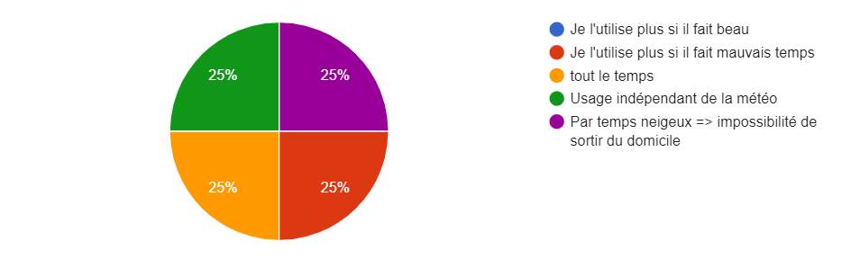

*Figure 11: Answers of EV users concerning the effect of weather on their EV use*

Calendar is the most important feature by increasing the overall R-score the most. Its impact can be seen in all feature combinations where it is present (see table 6).

*Table 6: Influence of features- Increase or decrease of R-Score for 1H and 3H prediction*

|  |  |  |  |  |
| --- | --- | --- | --- | --- |
| R-score | | | |  |
| **Model with the different features tested** | **1 Hour** | **% variation compared to consumption only** | **3 Hours** | **% variation compared to consumption only** |
| CNN LSTM consumption only | 0,2238 | - | 0,1211 | - |
| CNN LSTM cons+ solar no future | 0,1858 | -16,98% | 0,1080 | -10,82% |
| CNN LSTM cons+ solar future data | 0,1824 | -18,50 % | 0,0906 | -25,18% |
| CNN LSTM cons+ temperature no future | 0,1566 | -30,03% | 0,0925 | -23,62% |
| CNN LSTM cons+ temperature future data | 0,1472 | -34,23% | 0,0874 | -27,83% |
| CNN LSTM cons + calendar no future | 0,2336 | +4,38 % | 0,1023 | -15,52% |
| CNN LSTM cons + calendar future data | 0,2770 | +23,77 % | 0,1186 | -2,06 % |
| CNN LSTM cons+ calendar+ temperature future data | 0,2584 | +15,46 % | 0,1262 | +4,21 % |
| CNN LSTM cons+calendar+habits with future | 0,2701 | +20,69 % | 0,0618 | -48,96% |

The calendar feature reduces a lot of the otherwise big error sources such as covid-lockdowns, vacations, and closing hours. It is because of the clear connection between occupancy at school and the number of EVs parked these days and hours.

However, we can still observe (see Figure 12) that the lowest R-2 score occurs during the summer holidays and end-of-year holidays. This shows that the feature got room for improvement. The reasons behind this are probably connected to the fact that our occupancy calendar (explained in the methodology part) does not correspond entirely to the workers' schedule. In addition to this, since the school has few EV users, it would therefore be very plausible that changing our generalized calendar to the personalized schedule of the school's EV users could increase the impact of this feature.

*Figure 12: prediction and R2-score results (green curve) for the CNN-LSTM model with the calendar as a feature*

### image11.png

### 5.1.3. Issues with the habits feature

Another encountered problem was regarding the feature "user habits". Features strength depends strongly on the amount of information that it further brings to the model. For example, features with a lot of exact data points where the examples have different, and therefore interesting, values. This was unfortunately not the case for the "habits" feature. It can be explained by the fact that we assess this feature with a survey which resulted in only four total answers where two of which were "I do not know". Four answers are first of all too few to achieve an accurate representation of specific user habits. A higher participation percentage of the total EV users at school (estimated around twelve) should be necessary to identify a charging habit pattern. In addition to the few answers, two of them, in other words, half, were "I do not know". These "do not know" diminish the impact of the other answers which would increase the features' relevance. However, it is very hard to know exactly how the feature will affect the model. It is therefore always interesting, if possible and not too time-consuming, to analyze the feature by trying.

To improve this feature the survey should have been sent out earlier to obtain a higher response rate. In addition, an increase in charger users would greatly strengthen and clarify trends both for this feature and others such as consumption and calendar.

## 5.2. Problems Encountered

### 5.2.1. Understanding previous work

One of the earliest challenges encountered was understanding previous years' work and the best way to adapt their models and methodology to our task of forecasting EV charging load. The group's previous knowledge of machine learning was not sufficient to completely understand and further develop the last project's work. This resulted in some time being spent on learning and understanding the different methods, tools, and theories behind the topic and last year's work.

### 5.2.2. Lack of Data

One of the obstacles that we faced was the amount of data that we had to implement our model. The data that we had corresponds to almost two years of data. The amount and quality of data can significantly impact the performance of a machine-learning model. One year and a half will prevent us from seeing if there is an evolution in the consumption with the increase of users using EV chargers or with the weather impact that is globally linked with the season but can vary from one year to the other. If there is not enough data, the model may not have sufficient information to learn from and make accurate predictions. In some cases, a lack of data can lead to overfitting, where the model can make good predictions on the training data, but is not able to generalize well to new data. Moreover, the data that we have corresponds to the Covid year which means the use of the chargers relies a lot on unusual factors such as the number of people telecommuting and the different curfews and containment. As such, the data that we have are not all representative of the reality of the use of chargers and for some periods hardly usable. However, there are ways to mitigate the effects of a lack of data, such as using techniques like data augmentation or transfer learning. The use of these methods might be promising.

## 6. Conclusion

To conclude, our objective which was to build new forecasting models for the new EV data starting from last year's group models has been completed. We have been able to understand our set of data, preprocess them to remove outliers, and normalize them. We implemented the LSTM and CNN-LSTM models from last year's group with our data and concluded that the CNN-LSTM model was more promising.

From there, we explored the implementation of new features to improve the performance of this model. Features like calendar, solar irradiance and temperature were tested. The results showed that only the calendar features increased the performances. Thus, we tried to refine it by studying the charging habits of EV users. However, too few answers were received to implement the feature such that it would improve the performance of the model.

Another approach was explored: clustering. Instead of predicting values of consumption, we tried to predict levels of consumption. This approach seemed to produce a better prediction. However, the use of these models depends on what is required from the prediction. If "values" are absolutely needed then this approach is not possible. On the contrary, if users of the models can be satisfied with levels of consumption only this approach could be explored more thoroughly by another group next year.

Finally, it seems that the major issue encountered for our model is the lack of enough good-quality data. Data was only available for 2 years and contained exceptional events like COVID lockdowns. Data augmentation could thus be a promising approach to explore to increase the size of data available to train the model.

# 

# 7. Bibliography

[1] Reseau, de Transport d'Electricite-RTE. "Integration of electric vehicles into the power system in France-May 2019. Main results." (2019). Available at: <https://assets.rte-france.com/prod/public/2020-06/Rte%20electromobility%20report_-_eng.pdf>

[2] UK, GOV. "COP26 declaration on accelerating the transition to 100% zero emission cars and vans." *December* 6 (2021). Available at : <https://www.gov.uk/government/publications/cop26-declaration-zero-emission-cars-and-vans/cop26-declaration-on-accelerating-the-transition-to-100-zero-emission-cars-and-vans>

[3] IEA.” By 2030 EVs represent more than 60% of vehicles sold globally, and require an adequate surge in chargers installed in buildings”.(2022). Available at: <https://www.iea.org/reports/by-2030-evs-represent-more-than-60-of-vehicles-sold-globally-and-require-an-adequate-surge-in-chargers-installed-in-buildings>

[4] Ministry of Economic Affairs and Finance. “Infrastructures de recharge pour véhicule électrique*”*. (2020). Available at: <https://www.entreprises.gouv.fr/fr/infrastructures-de-recharge-pour-vehicule-electrique>

[5] Subasi, Abdulhamit. Chapter 2 - Data preprocessing, “Practical Machine Learning for Data Analysis Using Python”. Academic Press,.(2020),.Pages 27-89. doi: [10.1016/B978-0-12-821379-7.00002-3](https://doi.org/10.1016/B978-0-12-821379-7.00002-3).

[6] Twum-Duah, Nana Kofi, et al. "A Comparison of Direct and Indirect Flexibilities on the Self-Consumption of an Office Building: The Case of Predis-MHI, a Smart Office Building." *Frontiers in Energy Research* 10 (2022): 874041. doi: [10.3389/fenrg.2022.874041](https://dx.doi.org/10.3389/fenrg.2022.874041)

[7] F. Amara, K. Agbossou, Y. Dubé, S. Kelouwani and A. Cardenas,. "Estimation of temperature correlation with household electricity demand for forecasting application," IECON 2016 - 42nd Annual Conference of the IEEE Industrial Electronics Society. (2016). pp. 3960-3965. doi: [10.1109/IECON.2016.7793935](https://doi.org/10.1109/IECON.2016.7793935) .

[8] C. Vidal, O. Gross, R. Gu, P. Kollmeyer and A. Emadi, "xEV Li-Ion Battery Low-Temperature Effects—Review," in *IEEE Transactions on Vehicular Technology*, vol. 68, no. 5, pp. 4560-4572. May(2019).doi: 10.1109/TVT.2019.2906487

# 

# 

# 

# 

# 

# 

# 

# 

# 8. Appendix

## 

**Appendix 1:**

**Correction function to solve communication interruption in measurement of the data for charger 1 and 2**

import random

def correction(df, cols = ["Charger_1", "Charger_2"], upper_limit= 14 ):

indx = df.index

# df.reset_index(inplace = True)

for i in range(len(indx) - 1):

for col in cols:

hold = df[col][indx[i]]

# print (hold)

if hold > upper_limit and hold <= 21:

df[col][indx[i]] = 0

for x in range(2, -1, -1):

if hold > 7:

val = random.uniform(6, 7)

else:

val = hold

hold -= val

df[col][indx[i - x]] += val

#

elif hold > 21:

df[col][indx[i]] = 0

for x in range(2, -1, -1):

if hold - upper_limit > 0:

val = random.uniform(10.6, 13.94)

else:

val = hold

hold -= val

df[col][indx[i - x]] += val

#

else:

pass

df

return df

cons1 = correction(cons.copy())

df = pd.DataFrame()

df['Aggregate1'] = cons1.sum(axis = 1)

df['Sum']=(df['Aggregate1']-df['Aggregate1'].min())/(df['Aggregate1'].max()-df['Aggregate1'].min())

df.reset_index(inplace=True)

df

**Appendix 2:**

**Questionnaire used for the study of possible features affecting EV users**

“Afin de limiter l'impact de l'implémentation des énergies renouvelables sur le réseau, il est important d'optimiser l'utilisation de ces sources d'énergies renouvelables en favorisant l'autoconsommation. Ainsi, dans le cadre de notre projet de troisième année, nous cherchons à effectuer des prévisions de la consommation des stations de rechargement de véhicules électriques. Dans ce but, afin d'améliorer les méthodes de machine learning, l'habitude des utilisateurs qui a une influence non négligeable peut-être implémenter

Ce questionnaire succinct a pour objectif de déterminer quels habitudes pourraient avoir le plus d'impact sur la consommation des chargeurs.

1. Depuis quand avez vous commencé à charger votre véhicule électrique sur les chargeurs mis à disposition par l'école (environ)
2. Est-ce que la météo affecte l'utilisation de votre véhicule électrique ?
3. Combien de fois par semaine venez-vous en EV?

Moins d'une fois 0 1 2 3 4 5 Tous les jours

1. De quelle manière ?
2. Pour déterminer les paramètres influents sur l'utilisation du chargeurs, à savoir le calendrier

Y a-t-il des jours de la semaine au cours desquels vous utilisez plus le chargeur?

1. Pour déterminer les paramètres influents sur l'utilisation du chargeurs, à savoir le calendrier

Y a-t-il des jours de la semaine au cours desquels vous utilisez le plus souvent votre véhicule ?

1. Est-ce que l'évolution du prix de l'électricité a un impact sur l'utilisation de votre véhicule ?
2. Est-ce que le bon fonctionnement (pas de grève ou de travaux) des transports en commun affecte l'utilisation de votre véhicule ?
3. Est-ce qu'il y a un paramètre qui fait que vous n'utilisez pas votre véhicule électrique ?”

.